

National University

o f C o m p u t e r & E m e r g i n g S c i e n c e s - L a h o r e
 | Course – Section | Information Security (CS3002 - Fall 2025)
 | Assignment Number | 02
 | Total Marks | 70 Marks
 | Date Assigned | October 27, 2025
 | Due Date | October 31, 2025
 | Submission | Submit hand-written scanned softcopy in GCR.
 | Instructor | Nosheen Manzoor (nosheen.manzoor@lhr.nu.edu.pk)
 | TA | Ali Shahid(l215243@lhr.nu.edu.pk)
 | Submission Guidelines | - Write your name, section and roll number clearly at the top of your assignment, and staple your assignment properly.  - Assignments must be received before the deadline. Submit on time.  - Make assumptions where needed but state them clearly in your answer.  - Write and show clear steps of your working.  - Don’t write direct answers without showing proper calculations.  - Partial working will result into deduction of marks.

Q1. DES. [20 Marks]

By using the DES algorithm, perform encryption on the plaintext given below.
ONLY UP TILL ROUND 1.

PT = Smile Again! (Space and exclamation mark are also included in the PT)

Key:
0 | 0 | 1 | 1 | 0 | 1 | 0 | 0
0 | 0 | 1 | 0 | 1 | 1 | 0 | 1
1 | 0 | 1 | 1 | 0 | 1 | 0 | 1
1 | 0 | 1 | 0 | 1 | 0 | 0 | 0
0 | 0 | 0 | 1 | 1 | 1 | 0 | 1
1 | 1 | 0 | 1 | 1 | 0 | 1 | 1
1 | 0 | 0 | 1 | 0 | 0 | 0 | 0
0 | 0 | 0 | 0 | 0 | 1 | 0 | 0

Helping Material:
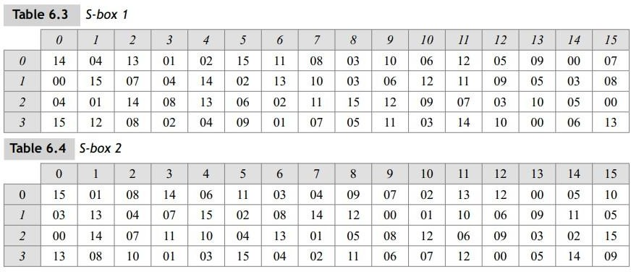

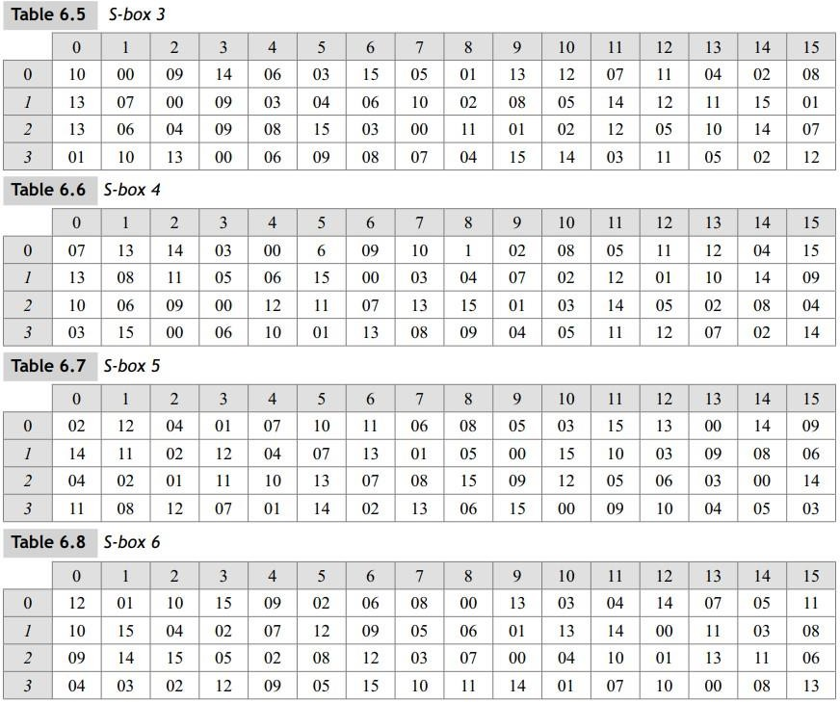
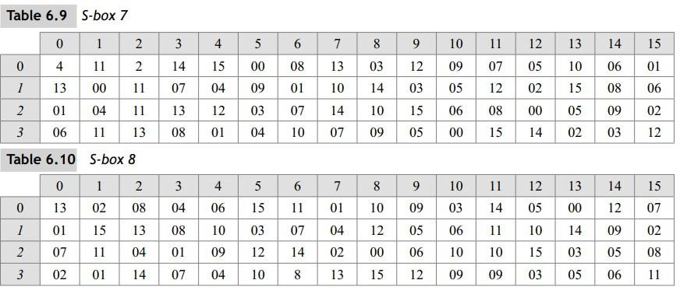

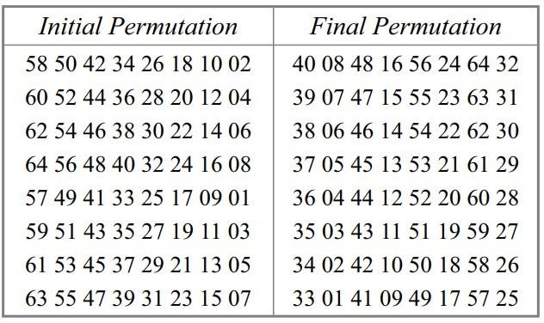

This Table is also called 𝑰𝑷−𝟏

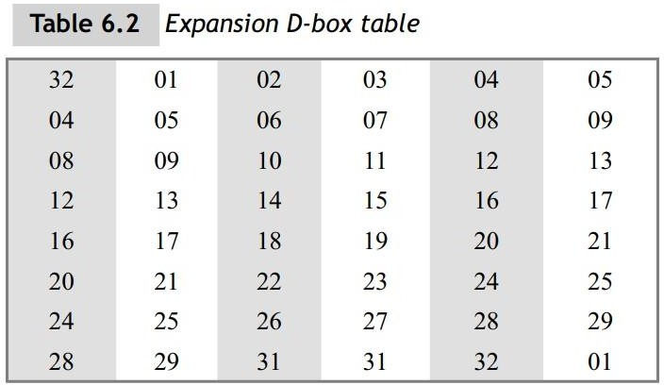

PC-1 PC-2
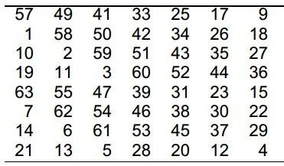
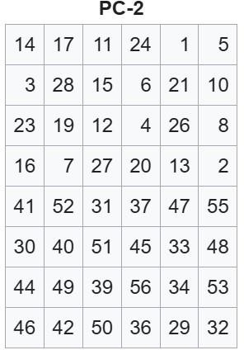

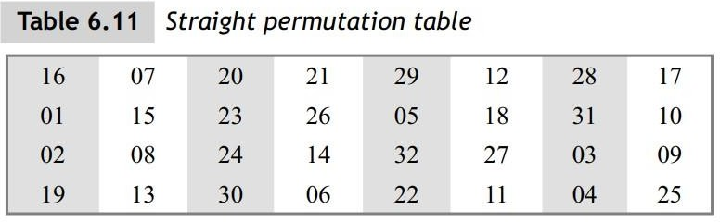

Malware
Q2. Case Study: (5 + 5 + 5) marks
An IT administrator at a mid-sized law firm notices that one workstation suddenly became slow and several shared network folders show files renamed with unusual extensions. A strange note appears on the affected machine demanding payment in cryptocurrency, it claims that some files were encrypted and provides instructions for contact. The firm’s backups for one critical project were recently failing due to a misconfigured backup job. The initial infected user reports having opened an email attachment that looked like an invoice from a regular vendor.
Network logs show the infected host contacting several internal IPs shortly before other machines exhibited similar symptoms.
Questions:
- Identify the most likely type of malware involved and list three key behavioral indicators from the scenario that support your identification.
- Explain how this malware typically propagates within a corporate network after initial compromise. Describe at least two common propagation techniques.
- Recommend four prevention or detection techniques that the firm should implement immediately to reduce impact and prevent recurrence (include at least one technical detection/control, one backup/recovery action, and one
organizational/process change).

Memory Safety.
Q3. Answer the given questions according to the following code. (2 + 3 + 5) marks

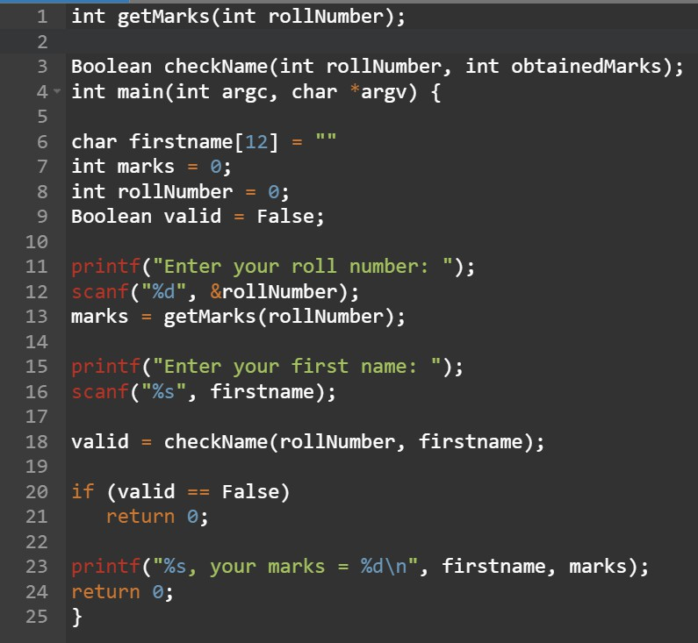
Code:
- Depict how the stack(Draw the diagram) frame for main() will look after the local variables are allocated.
- Identify and explain the problems in the code. Give at least three issues.
- Explain how you could exploit firstname input to make the program print the name and marks even if checkName would normally return False. Describe exactly what you would input and show why that changes program flow.

Q4. Case Study (5 + 5 marks)

A financial software system written in C was found to be vulnerable to a buffer overflow attack. Attackers exploited a lack of bounds checking in a function that copied user input into a fixed-size stack buffer. By entering an excessively long string, they were able to overwrite the return address on the stack, redirecting program execution to malicious code injected within the same buffer. This allowed the attacker to gain administrative privileges and execute arbitrary commands on the server.
Question:
  - Explain the working mechanism of buffer overflow attacks and how they can lead to control hijacking.
  - Discuss at least two compile-time or run-time defense techniques that could have prevented or mitigated this attack.

Q#3.[Marks=15]
Take any Malware and load it in Isolated environment and perform its dynamic analysis and make a report about the behavior of your system with screen shots.

https://github.com/topics/malware-samplesand and https://virusshare.com/

